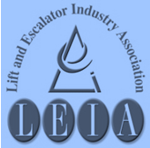
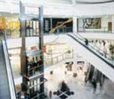
S

The Lift & Escalator Industry Association
SAFETY Matters
January 2016

Tel: 020 7935 3013
Fax: 020 7935 3321
Email: enquiries@leia.co.uk

Contents
- Winter Driving
- 2014/15 Injuries
- Annual workplace injuries
- Chemical Labelling and packaging
- Asbestos Awareness
- Blood Pressure
Introduction
Welcome to the January 2016 edition of Safety Matters.
Through this newsletter our aim is to inform you of health and safety issues that may have an impact on the lift and escalator industry. Safety Matters is also available for download from the LEIA member’s website. www.leia.co.uk

Driving in the Snow and Ice
Don’t be fooled into thinking that the recent snowfall is all you are likely to get this winter. Snow fell on 6th June in Scotland in 2009.
This is what the Institute of Advanced Motorists recommends:

When driving in snow, get your speed right - not too fast that you risk losing control, but not so slow that you risk losing momentum when you need it - and brake, steer and accelerate as smoothly as possible.
Start gently from stationary, avoiding high revs. If you get yourself into a skid the main thing to remember is to take your foot off the pedals and steer. Only use the brake if you cannot steer out of trouble.
Double or triple your normal stopping distance from the vehicle in front. Drive so that you do not rely on your brakes to be able to stop - on an icy surface they may simply not do that for you!
If your vehicle has ABS in very slippery conditions it will not give you the same control in others. Do not rely on it.

Plan your journey around busier roads as they are more likely to have been gritted. Avoid using shortcuts on minor roads - they are less likely to be cleared or treated with salt, especially country lanes.
On motorways stay in the clearest lane where possible, away from slush and ice.

Keep within the clear tyre tracks if you can.
Stay in a higher gear for better control, and if it is slippery, in a manual car move off in a higher gear, rather than just using first.
On a downhill slope get your speed low before you start the descent, and do not let it build up - it is much easier to keep it low than to try to slow down once thing get slippery; in falling snow used dipped headlights or fog lights to make yourself visible to others (especially pedestrians) - but as conditions improve make sure your fog lights are only on if necessary as they can dazzle other drivers.
If you are following another vehicle at night, using their lights to see ahead can cause you to drive dangerously close - keep well back from other traffic.

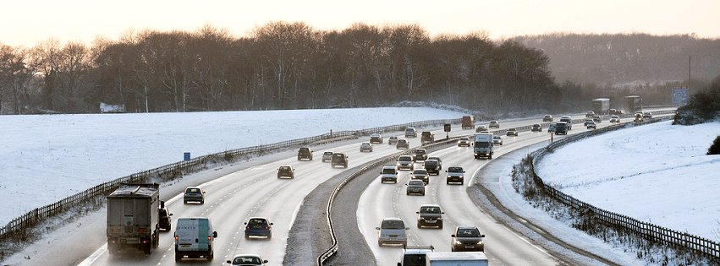

Highways Agency

Mental Health
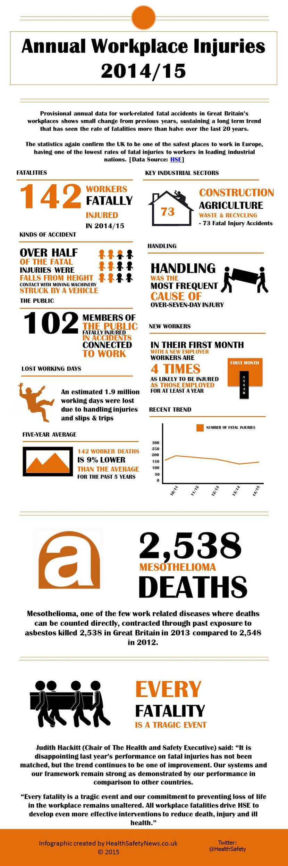
Thanks to Healthandsafetynews.co.uk for
PPE provided but was it the correct type?
A building company firm has been fined for safety failings after an employee suffered permanent injury to his eye from lack of correct protection.
Luton Magistrates’ Court heard how an employee, was injured when he was hit in the eye by a shard of metal when a work colleague was operating a nail gun to fasten a piece of timber to a steel lintel. The court also heard that the eye-protection being worn by the nail gun operator, being lightweight ‘spectacle’ types rather than impact absorbing ‘goggles’, were not adequate for use with nail guns.
The employer, was fined a total of £6,500 and ordered to pay £898.20 in costs after pleading guilty to an offence under Regulation 4(1) of the Personal Protective Equipment at Work Regulations 1992.
Main contractors some times impose a blanket PPE requirement for everyone on site but this may not cover particular tasks where the risks involved require a higher level of protection. If in any doubt about the suitability of PPE provided contact your company safety person.
Needles/syringes within a pit
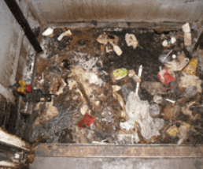
Unfortunately, this is not an uncommon occurrence any more and these materials are often encountered. For further information as to how to proceed in these situations, refer to LEIA Lift Safety Site Handbook or your company safety person
A LEIA Safety information sheet (Sharps) is also available on the website.

use of the above graphic
1. 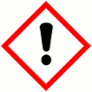 2. 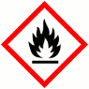 3. 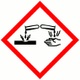

4. 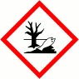 5. 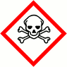 6. 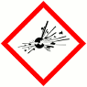

7. 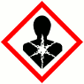 8. 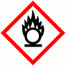 9. 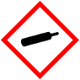

Chemical labelling and packaging
From 1 June 2015, the symbols attached to the packaging of hazardous chemicals have changed . The old black on orange ones have gone being replaced by black on a white background within a red diamond. You may see these symbols . Do you know what they all mean? Answers at bottom of last page
Further information available from HSE website, see link below: http://www.hse.gov.uk/chemical-classification/labelling-packaging/hazard-symbols-hazard-pictograms.htm

Asbestos Awareness Training

Employers (including the lift companies) have a duty to ensure their employees (who are or who may be liable to be exposed to asbestos) are provided at regular intervals with sufficient information, instruction and training to make them aware of the health effects of asbestos, where it is likely to be found, when it is likely to be disturbed, the procedure to deal with an emergency and the safe working practices to be adopted.
Such training is referred to as Asbestos Awareness Training and should be given to persons liable to disturb asbestos while carrying out their everyday work and those supervising the work.
It is recommended that Asbestos Awareness
Training is provided for lift maintenance and repair engineers and their supervisors. LEIA has produced an Asbestos Awareness training package which is intended to make those in the industry aware of asbestos.
Asbestos Awareness Training is of particular value to workers in domestic premises where no assessment or management plan may be available and where the householder may be unaware themselves of the presence of asbestos containing materials
A Safety information sheet is available giving further details and a separate information sheet is available aimed at Client’s and explaining their responsibilities.

A few examples above of where asbestos containing materials may be found in older lift equipment but beware it can be found anywhere.
Blood pressure

High blood pressure isn’t usually something that you can feel or notice, but if you have it you’re more likely to have a heart attack or a stroke.

The good news is there are lots of things you can do to help lower your blood pressure so your risk is lower. You’re in control. By taking ten minutes every day to make small changes to your lifestyle, you could lower your blood pressure – and change your life. The booklet opposite is free to download from BHF website.

To find out more about blood pressure and eating well, being active, and giving up smoking, go to bhf.org.uk/ten or ring the BHF Heart Helpline on 0300 330 3311.
Lines are open 9am – 5pm Monday to Friday
at a similar cost to 01 or 02 numbers.
Your doctor or nurse should also be able to
give you more information about things you
can do to help lower your blood pressure.

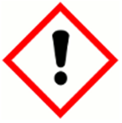
Answers to Hazard symbols
1. Harmful & Irritant 2. Flammable 3. Corrosive 4. Harmful for the environment
5. Toxic 6. Explosive 7. Respiratory & Carcinogenic 8. Oxidising 9. Contains gas under pressure

